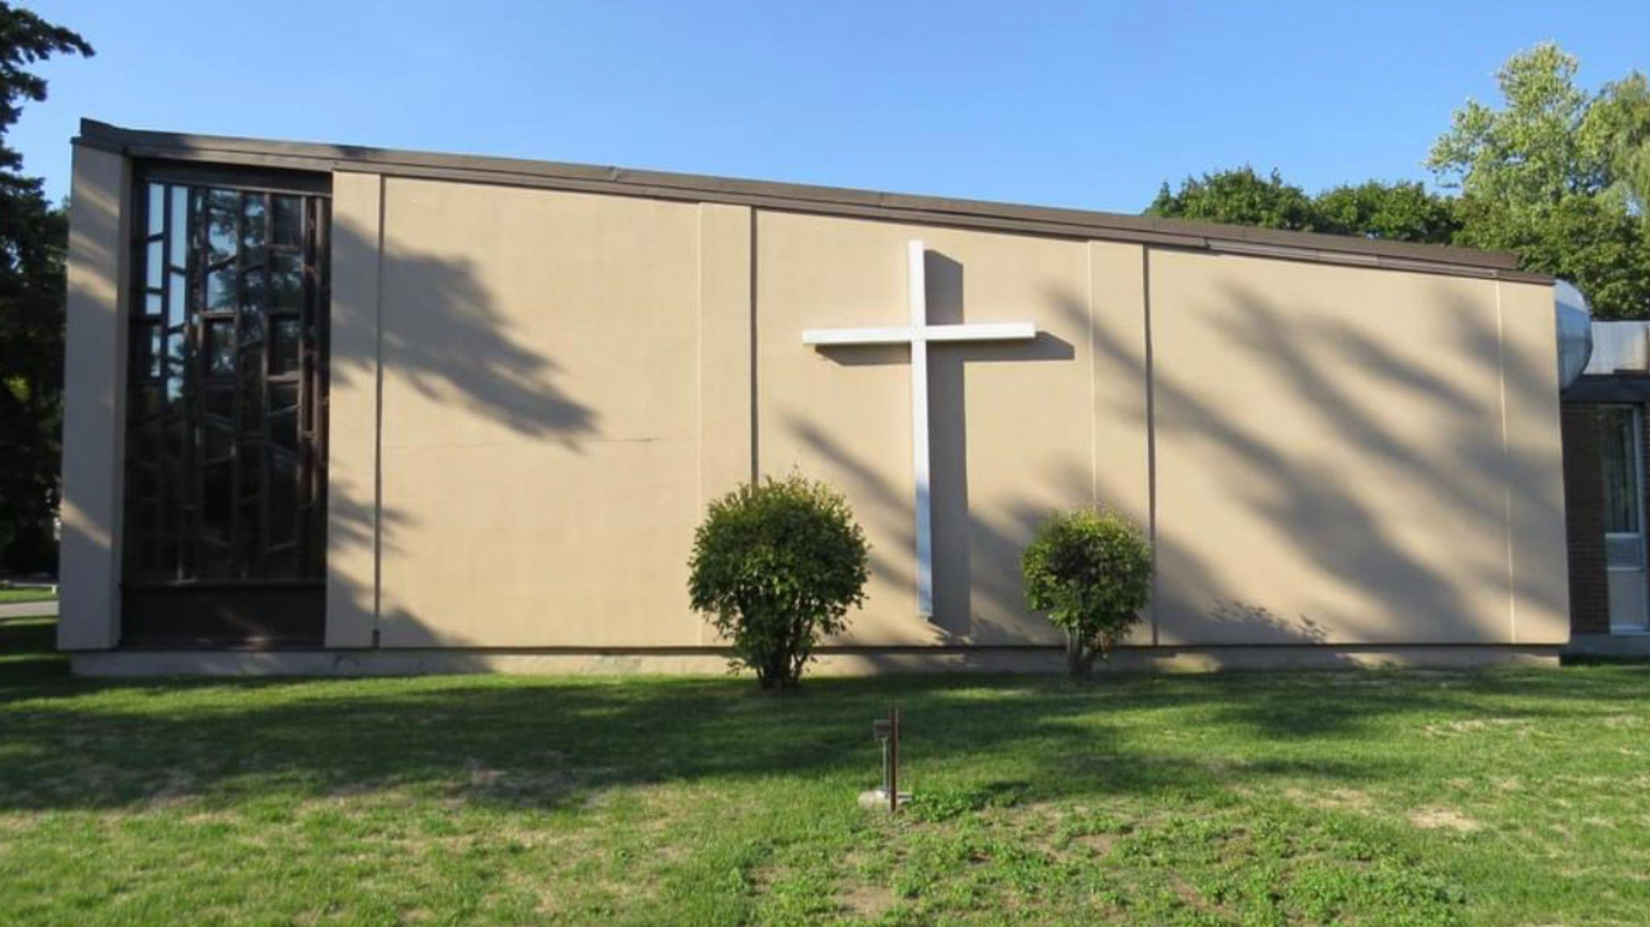
The Summer
Thornhill Lutheran Church

149 Bay Thorn Dr. Thornhill, ON
Website: www.thornhill-lutheran.org
E-mail: office@thornhill-lutheran.org
Instagram: thornhill_lutheran_church
Facebook: Thornhill Lutheran Church
Office: 905-889-0873

A word from Church Council
We would like to thank all our talented members who have stepped up and have helped out in many rolls in the last few months, from helping out with our services to donating cakes, sandwiches and cookies for our Coffee and Cake time.
Please see the Spring Clean Up Sheet, as many jobs still need to be done.
You can listen every Sunday Morning at 10:00 am.via our Audio Stream at: https://www.thornhill-lutheran.org/web-stream.htm
TOWN HALL
MEETING
Sunday June 4th
After the Church Service with Potluck
Cake and Coffee
Come share your ideas and concerns!

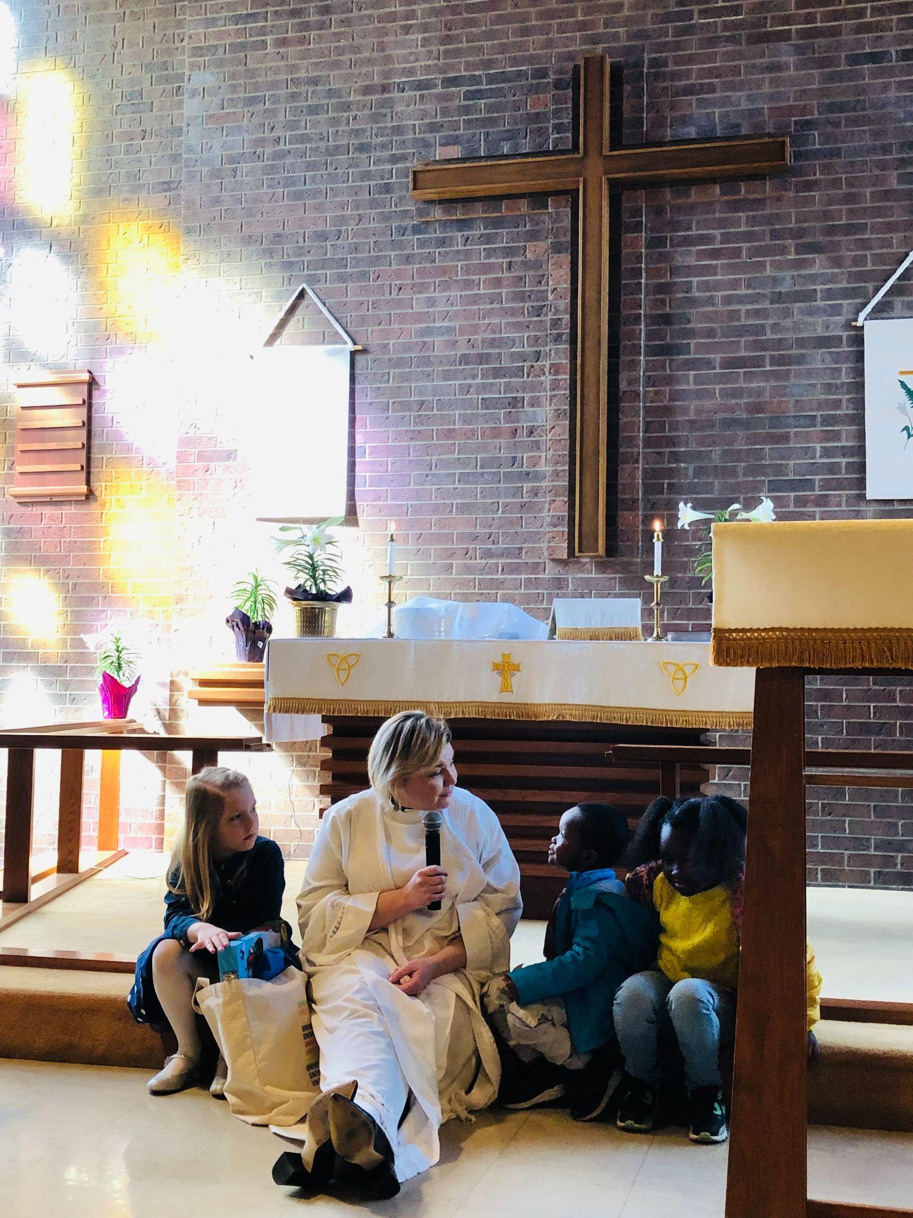
Easter - Pastor Hilla

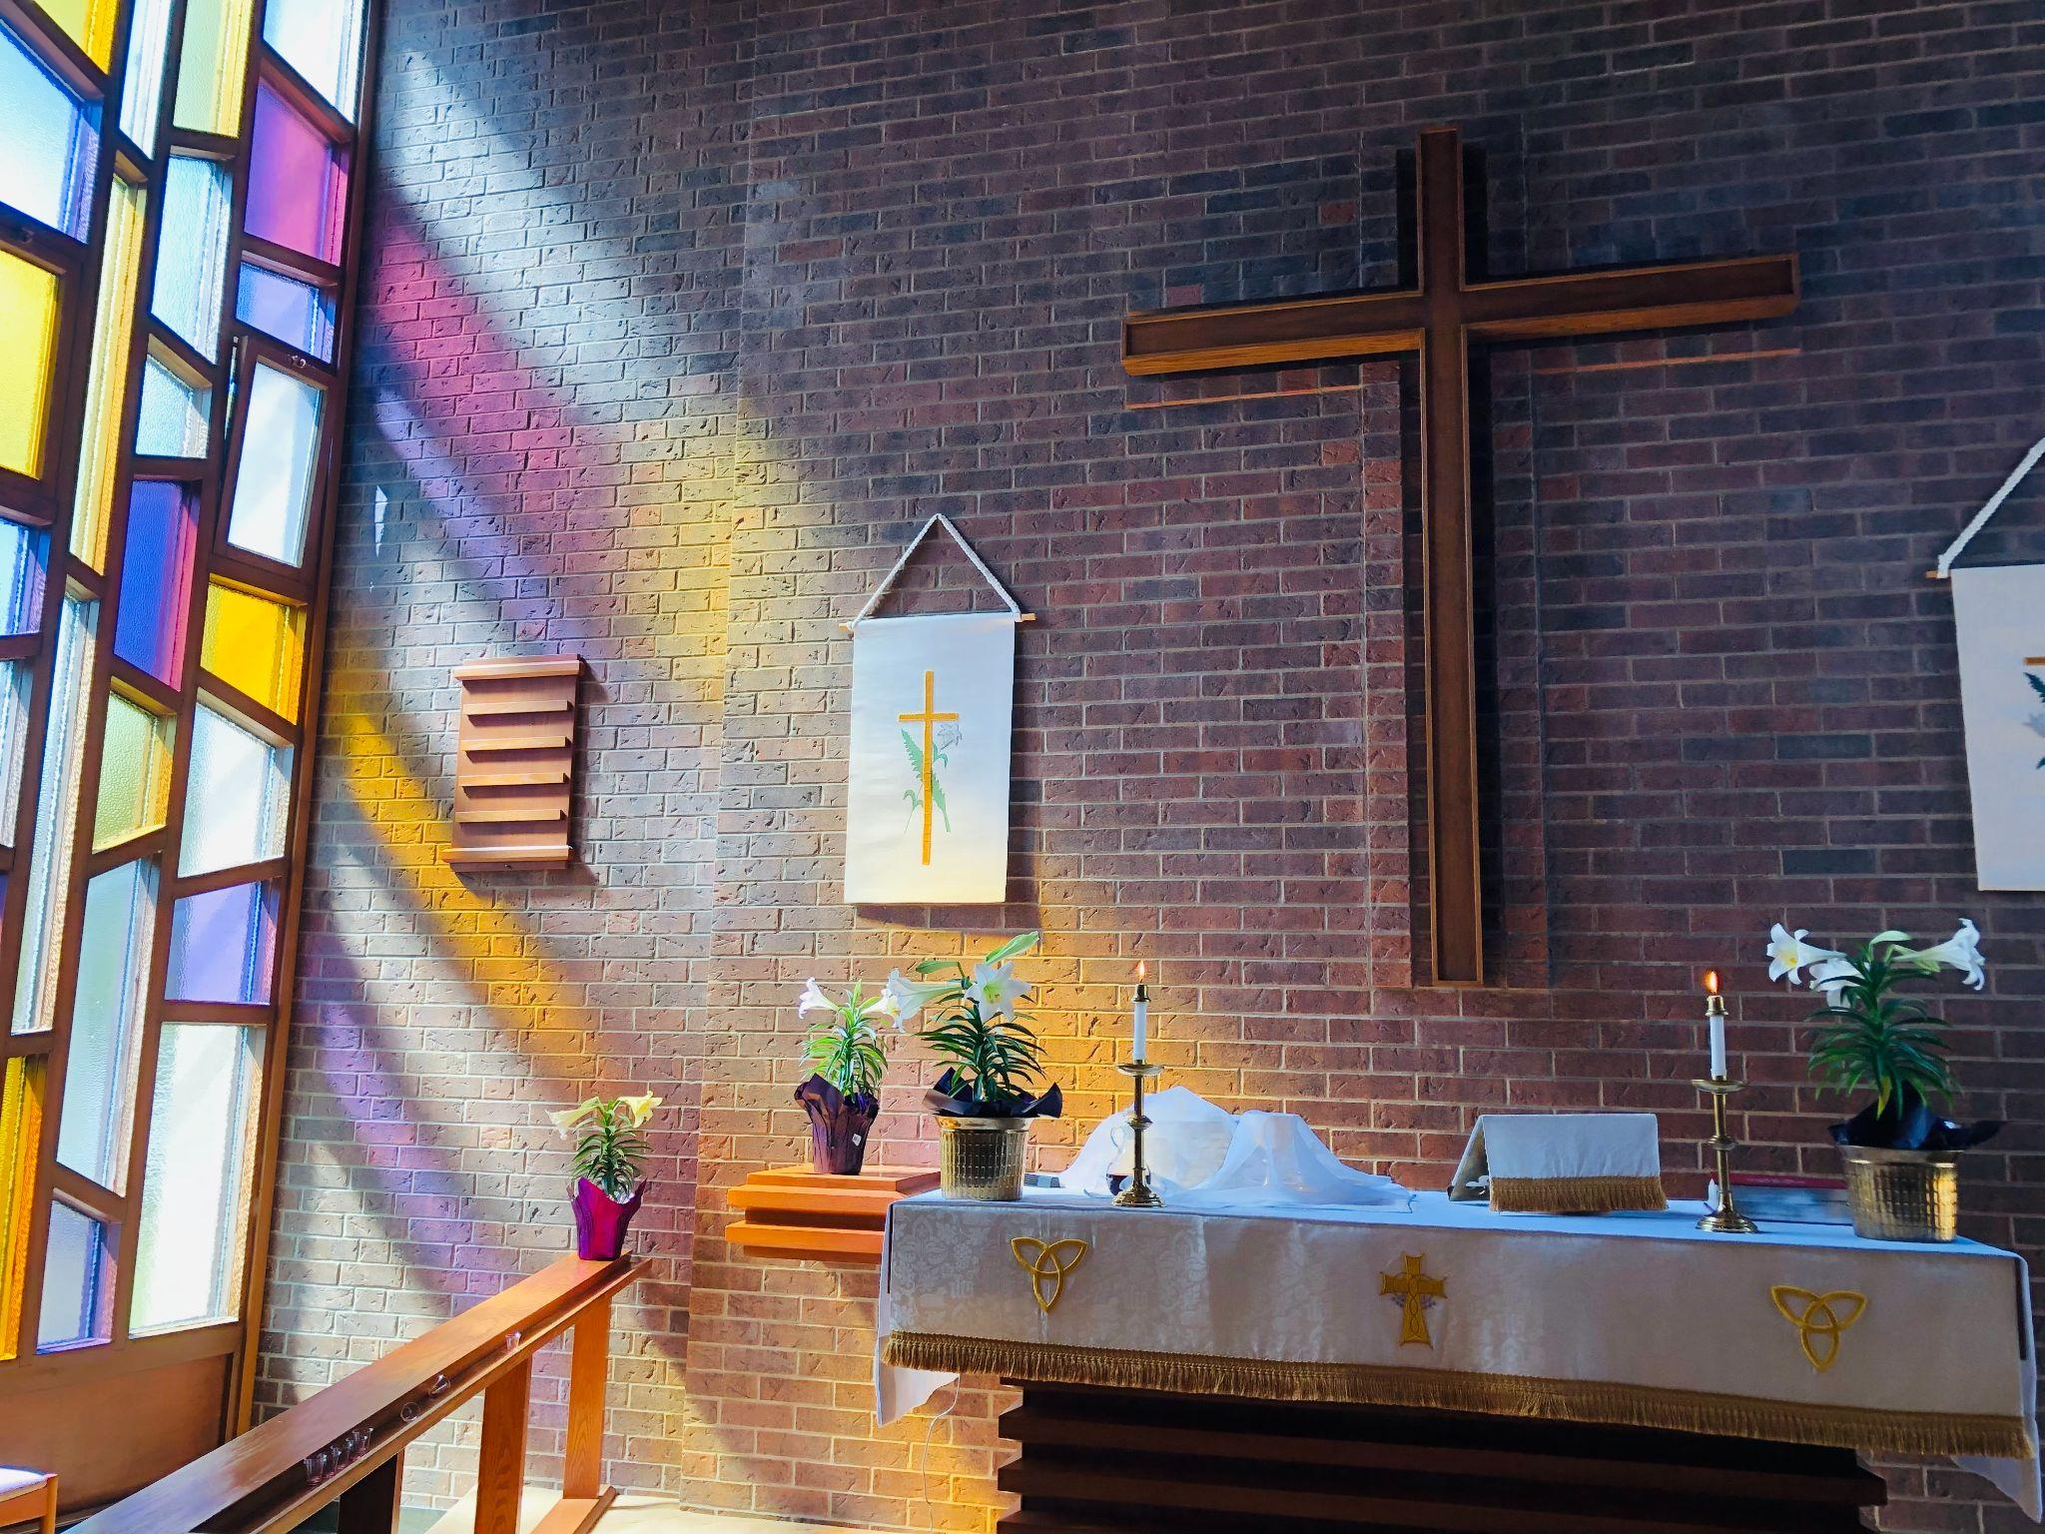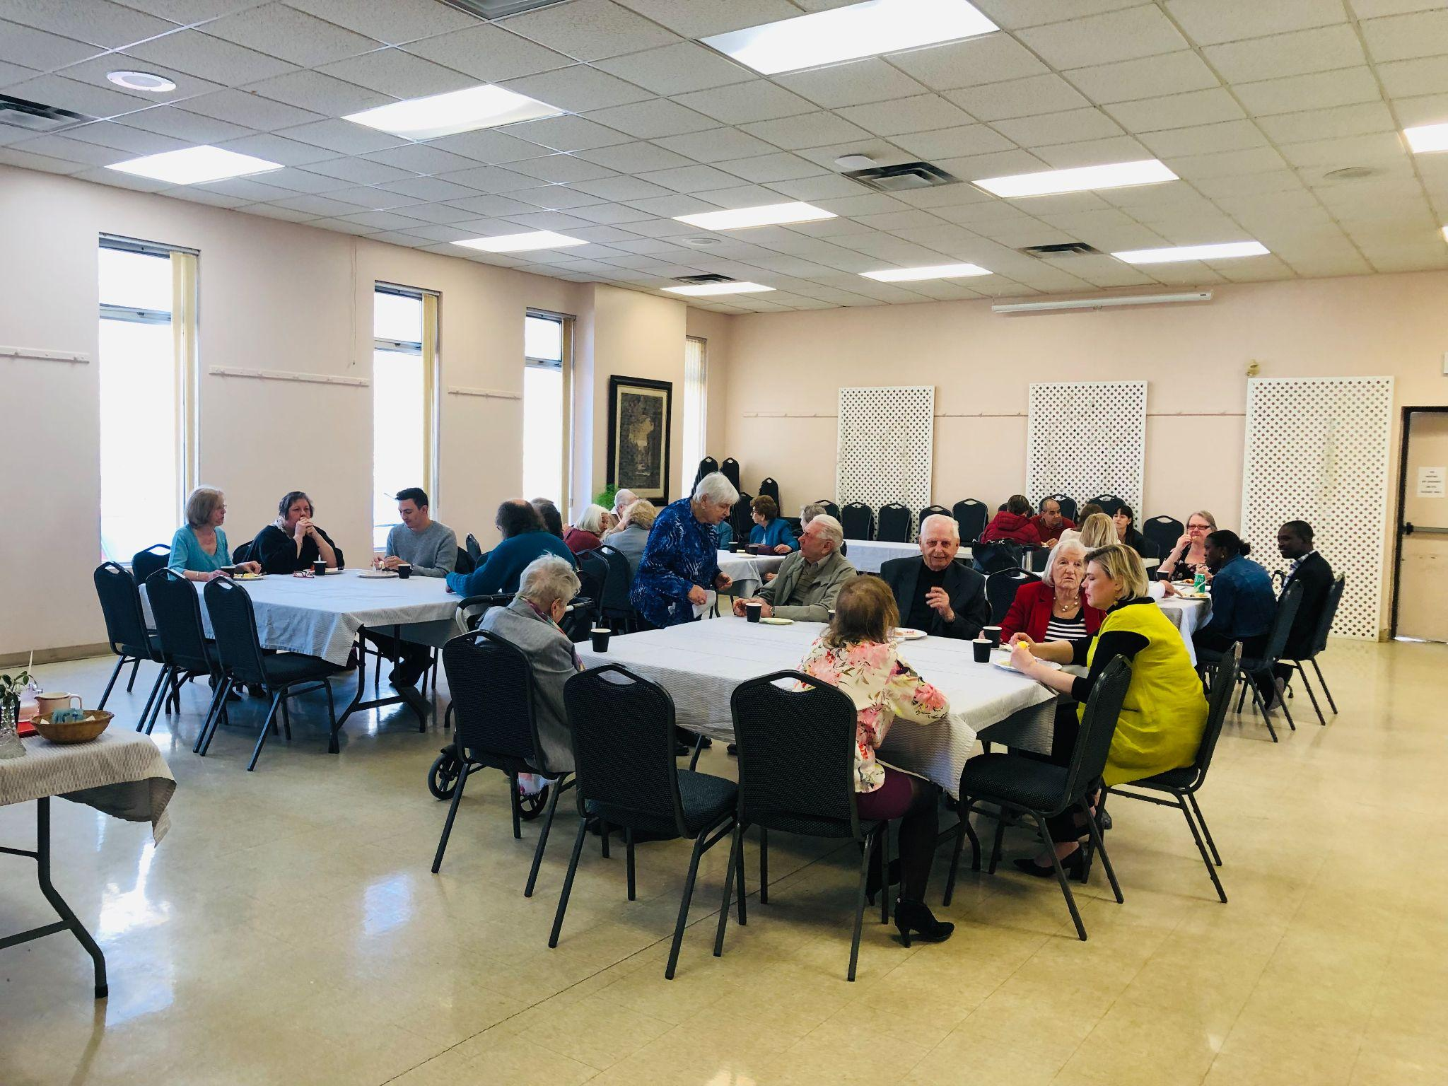
Mother’s Day Potluck
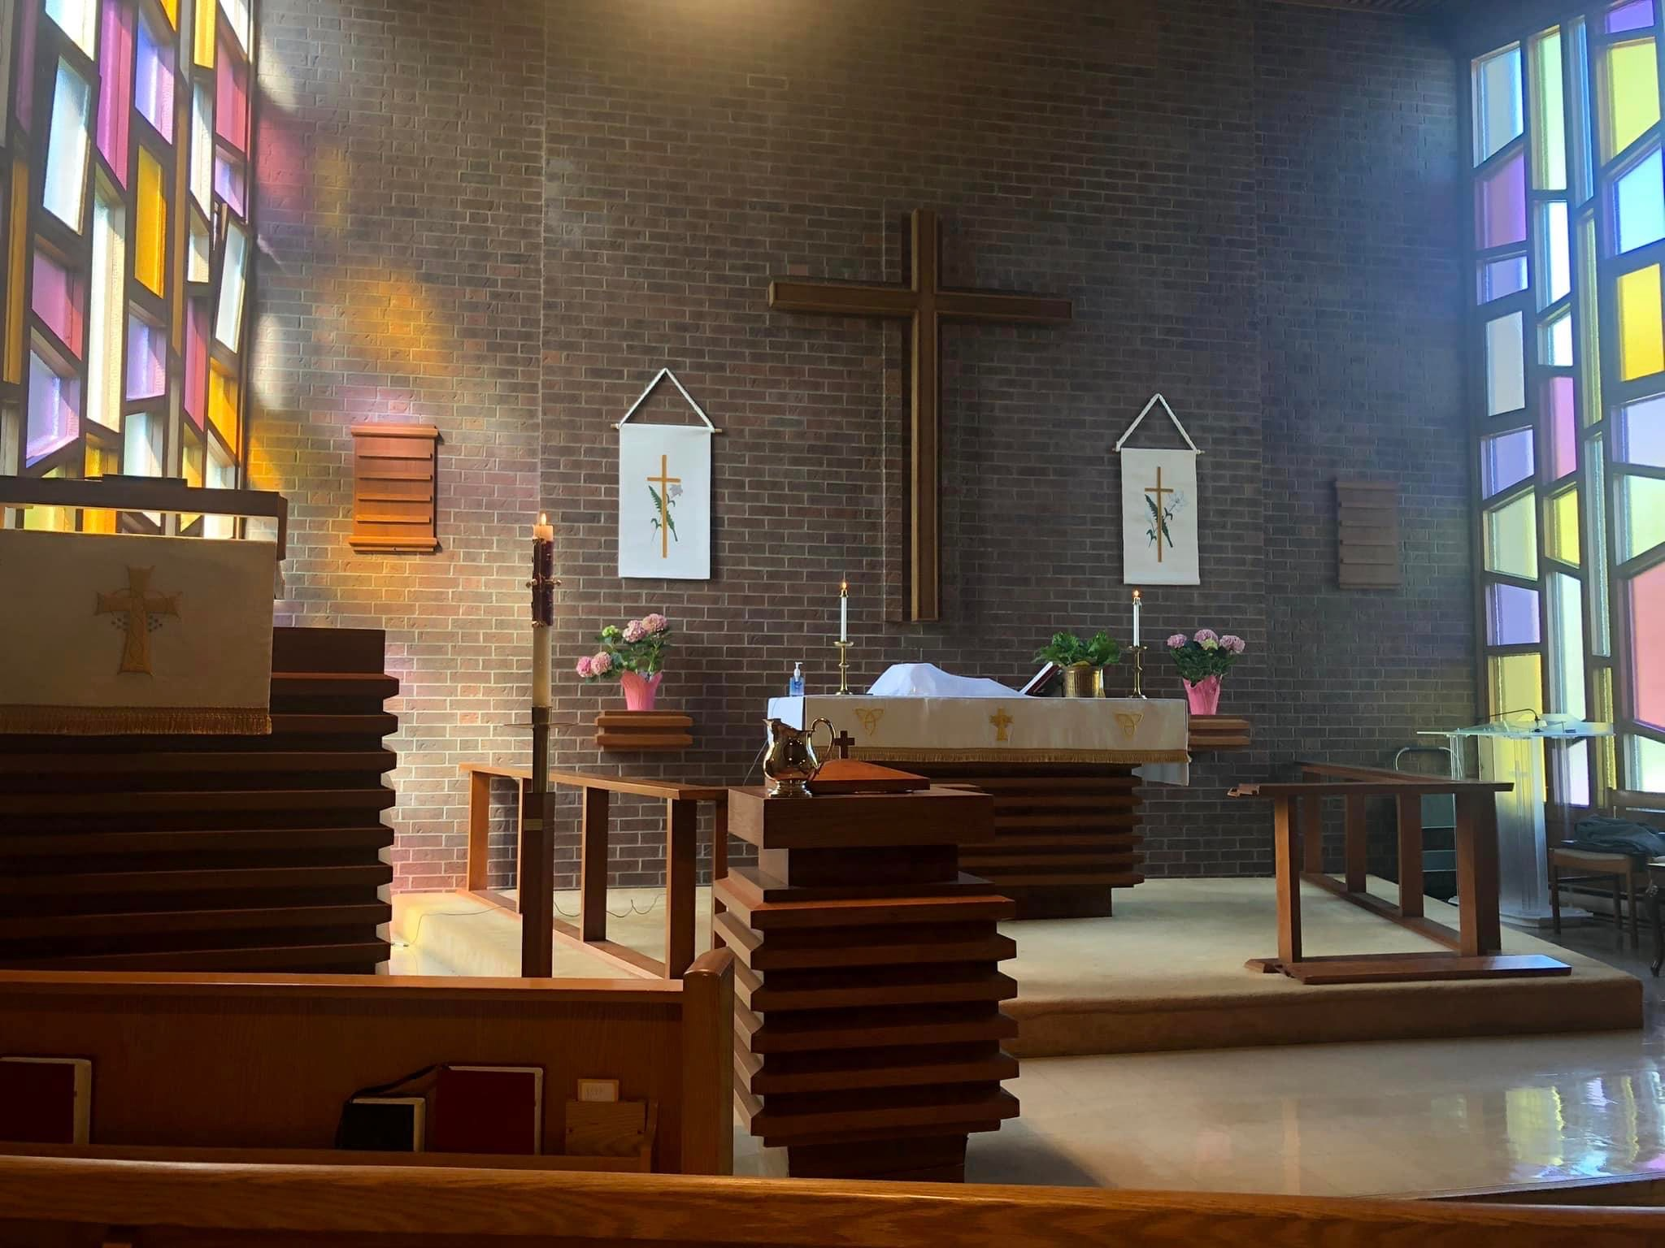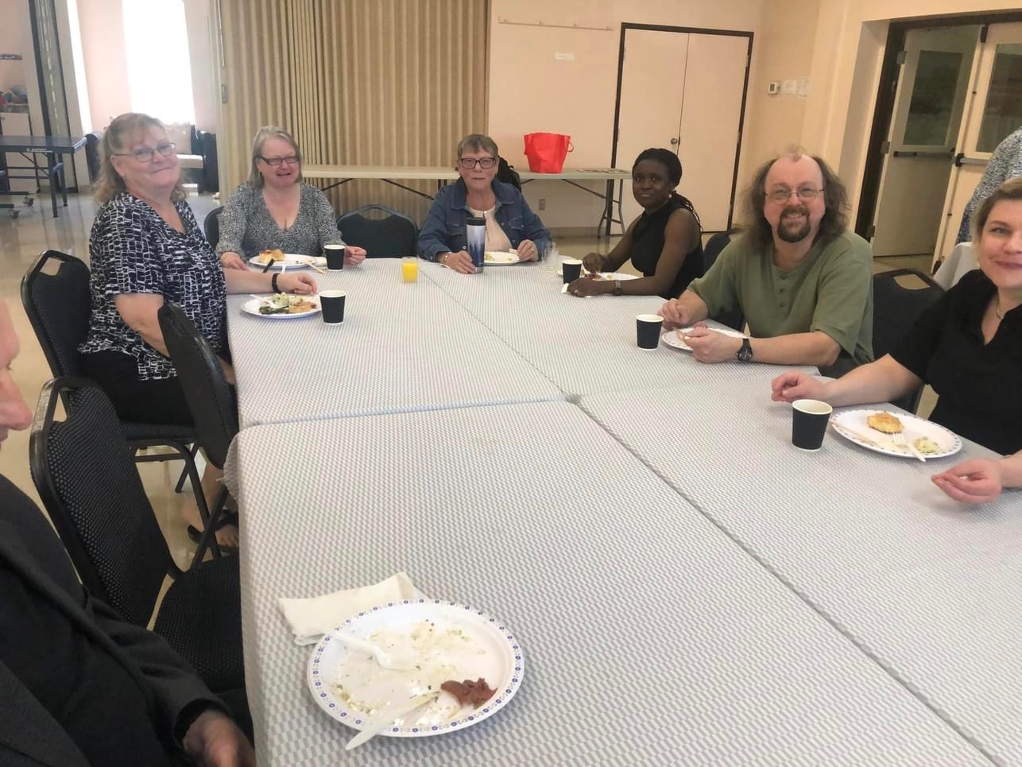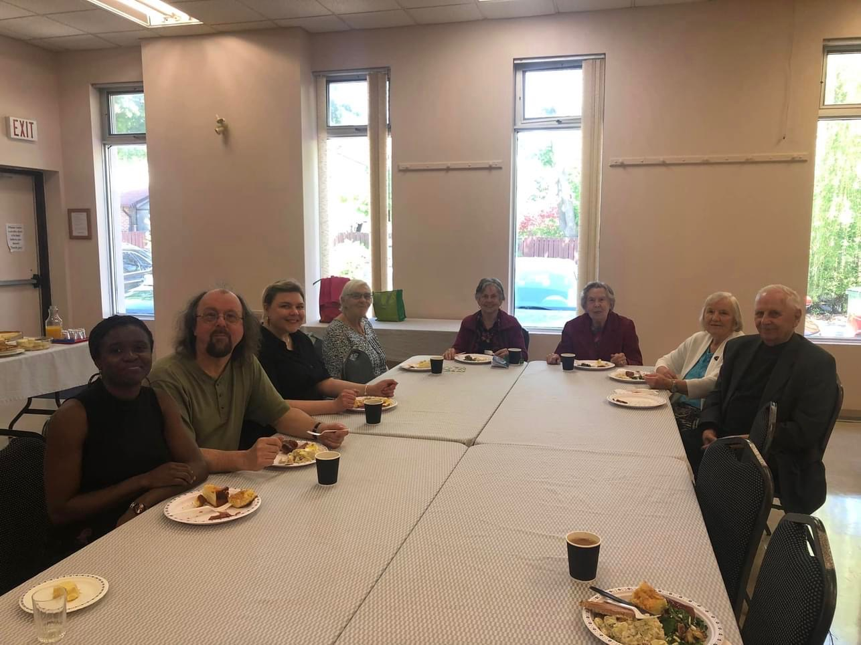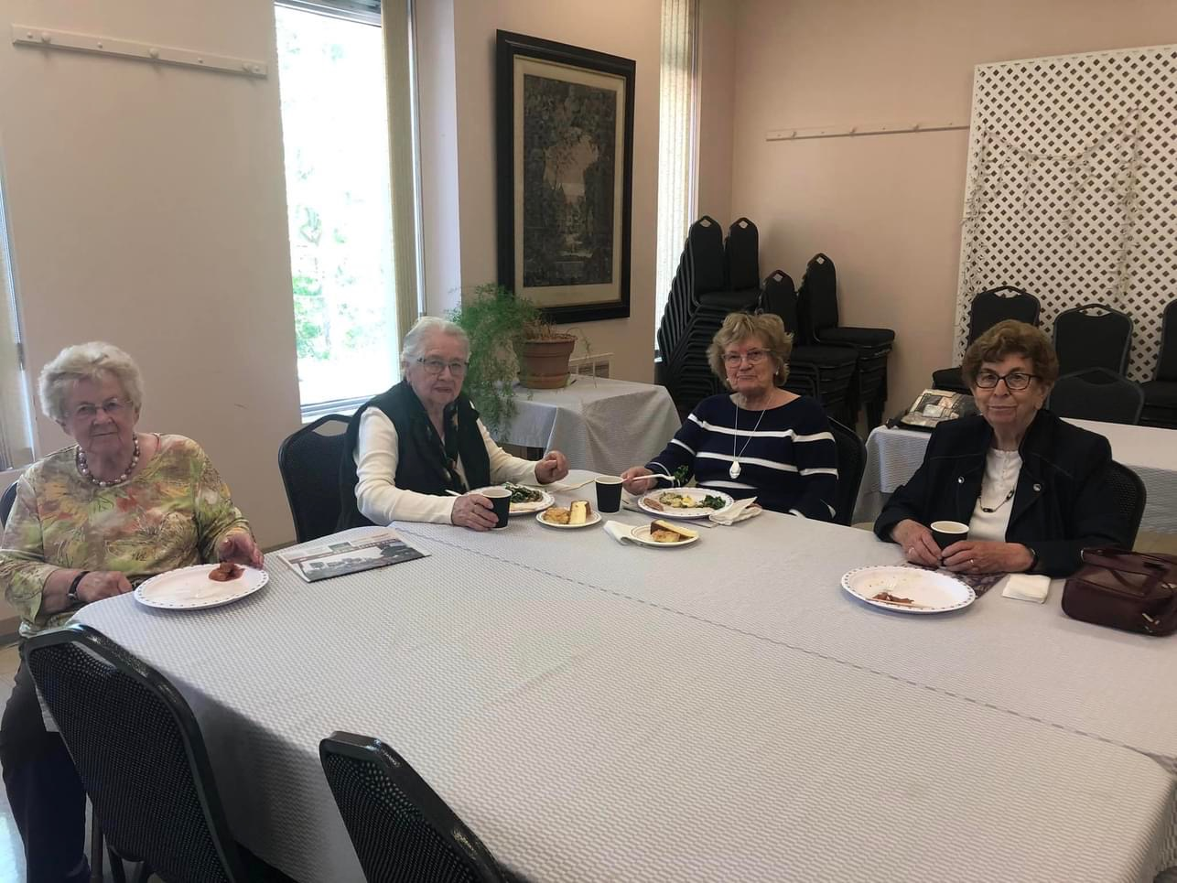
Church Council Highlights
April
- Started the process of the Church Mission Profile
- Organized a Town Hall Meeting for May 28, 2023
- Spring Cleaning dates
- Health and Safety - New Fire Extinguishers, disposal of old ones and New First Aid Box
- Potluck Luncheons for Mother’s Day and Father’s Day
- June 11th - BBQ and Potluck after church
- Organizing the roof repair
- Looking at organizing a Welcome Back to Church Potluck Sept. 17th
- Appreciation Sunday Service in the Fall
- Rental Fees for Hall Adjusted
- Still looking for members to join the Property Committee
May
- Reviewed Focus group meeting
- What our steps are from the Focus group
- Organized the Town Hall
- Looked at the summer services and the invite from St. Paul’s
- Support Newlight having a yard sale, to raise funds for their mission trip to Nicaragua
- Printer needs a check up
- Leaking roof, has been checked and now just waiting for final repair
- Fire extinguishers were purchased
Looking for Painters and HandyMen
Door frames and bathrooms need to be painted
Focus Group
At the Annual Meeting, the Church Council discussed forming a Focus group to discuss the future of our church and our options. These are the members who joined the Focus Group.
Our members are: Ruth Boothby, Edith Schiller, Fiona Tobin, Doris Lottermoser, Monika Bos and Nancy Moulson
Upcoming Events

1.) Sunday June, 11, 2023 - BBQ and
Potluck following the service
2.) Frohe Runde will meet on Saturday, June, 17, 2023 at 2:00pm - 4:30pm
3.) Sunday June 18, 2023 - Father’s Day Cake and Coffee following
the service
4.) Church Council Meeting Wednesday June, 21, 2023 at 7:30pm
5.) Church Council Meeting August, date to be determined
6.) Sunday Sept, 17, 2023 - Welcome back to Church - Potluck
following the service
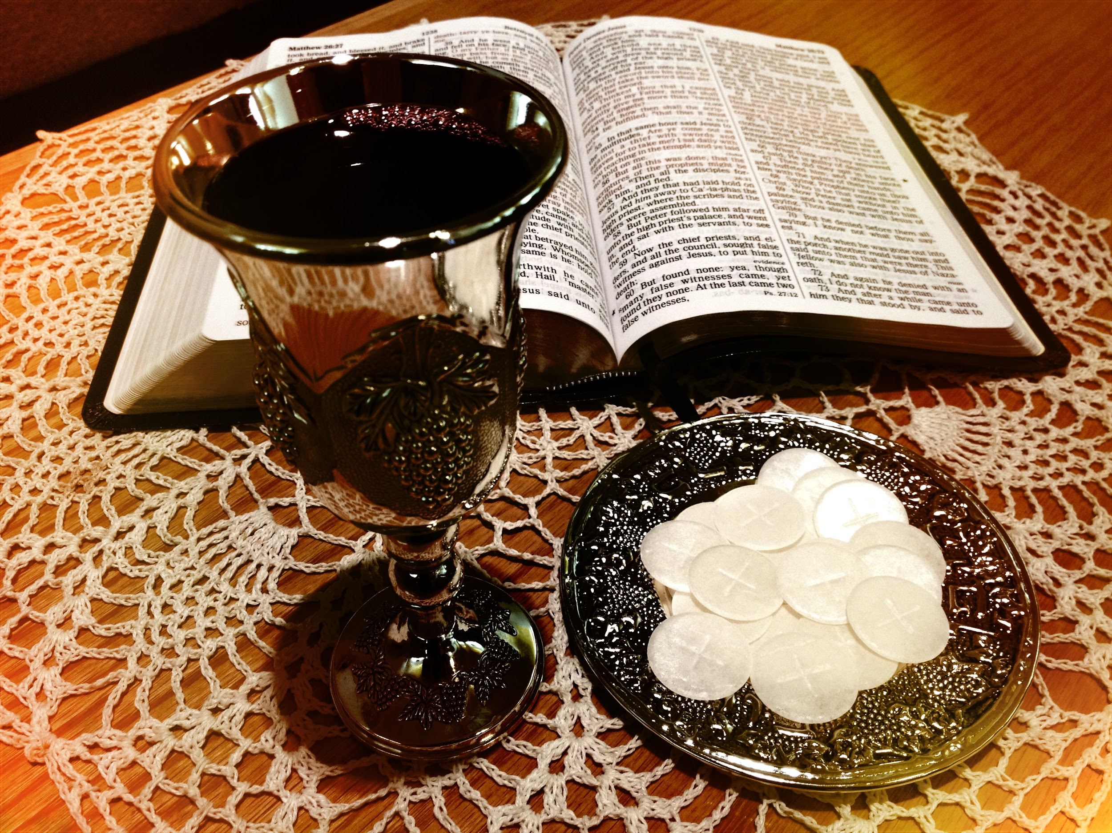
Upcoming Services Led by a Pastor

- Sunday June, 4, 2023 at 10:00am - Pastor
Ernie Skujins English Service with Communion
Town Hall following the service with Cake and
Coffee
- Sunday June, 11, 2023 at 10:00am - Pastor Hilla Lahtinen English Service with Communion
- Sunday July 9, 2023 - Pastor Hilla Lahtinen English Service with Communion
- Sunday August 06, 2023 - Pastor Hilla Lahtinen English Service with Communion
Our Guest Pastors

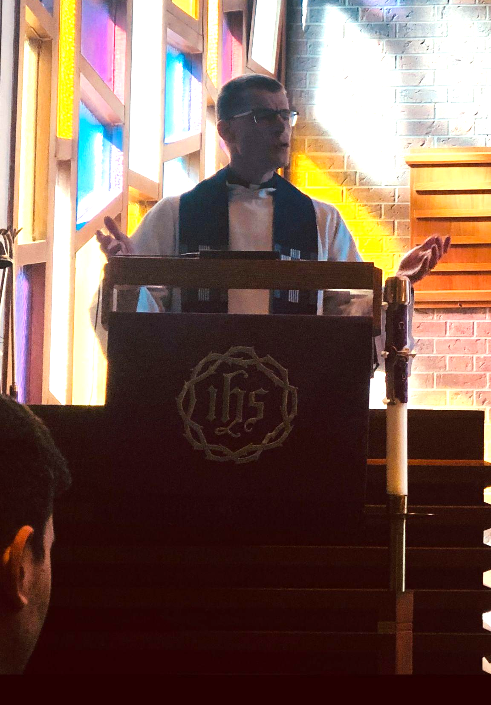
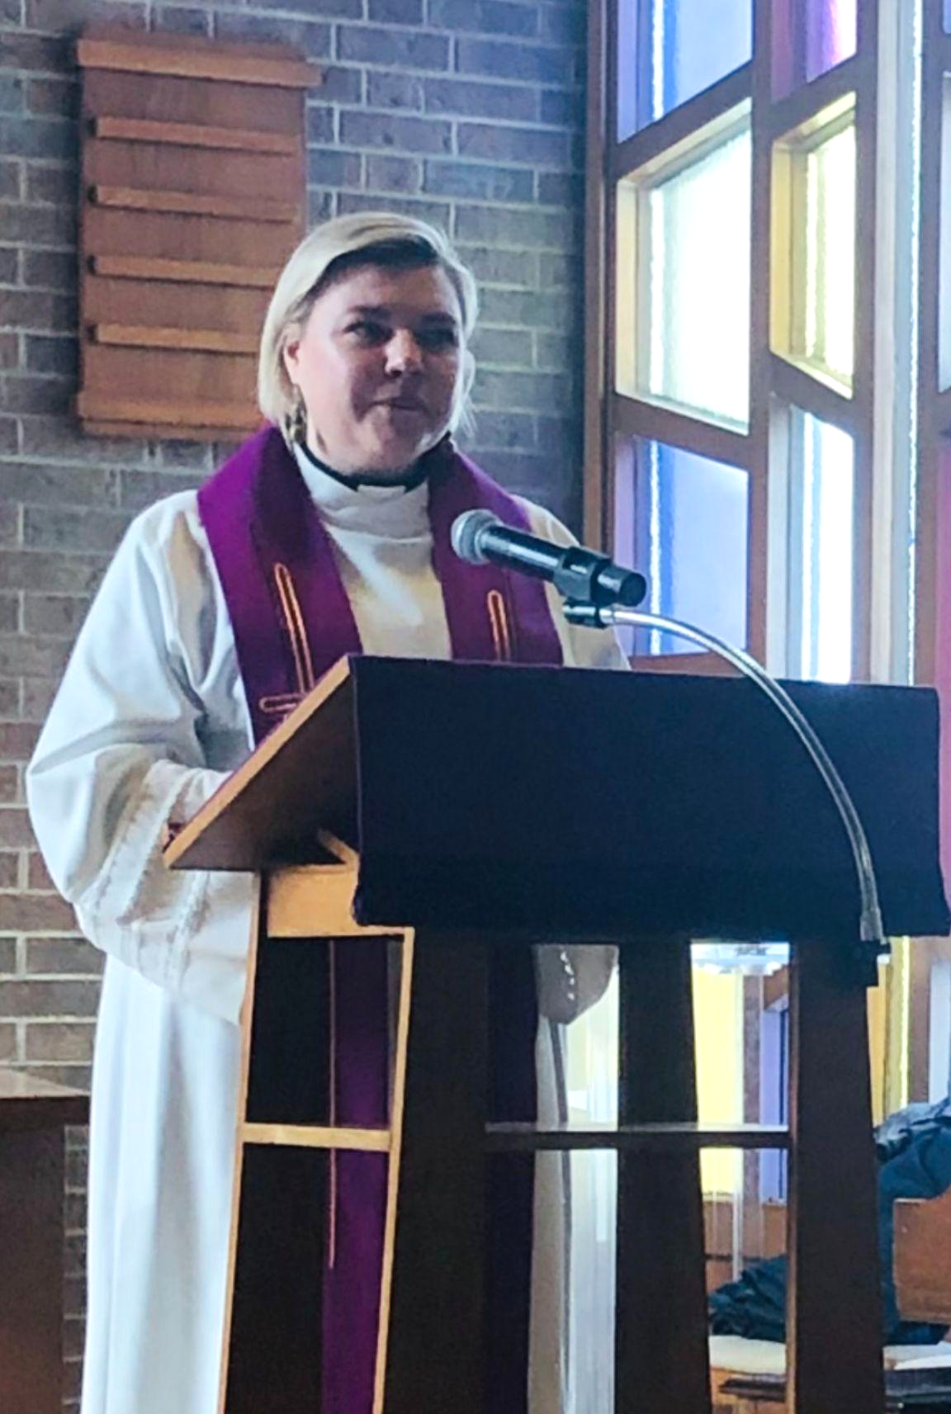
Pastor Hilla Lahtinen Pastor Eric Schultz

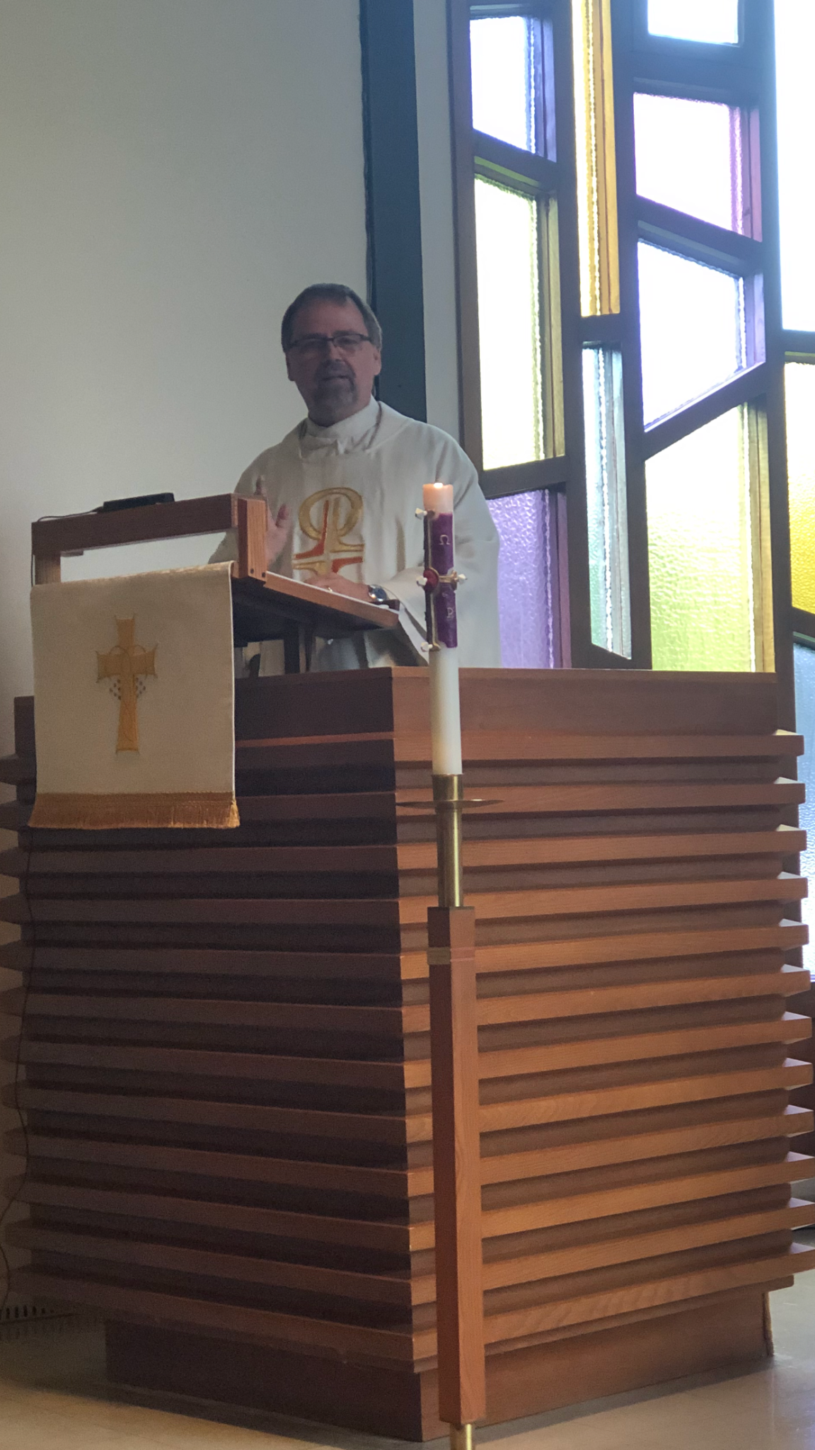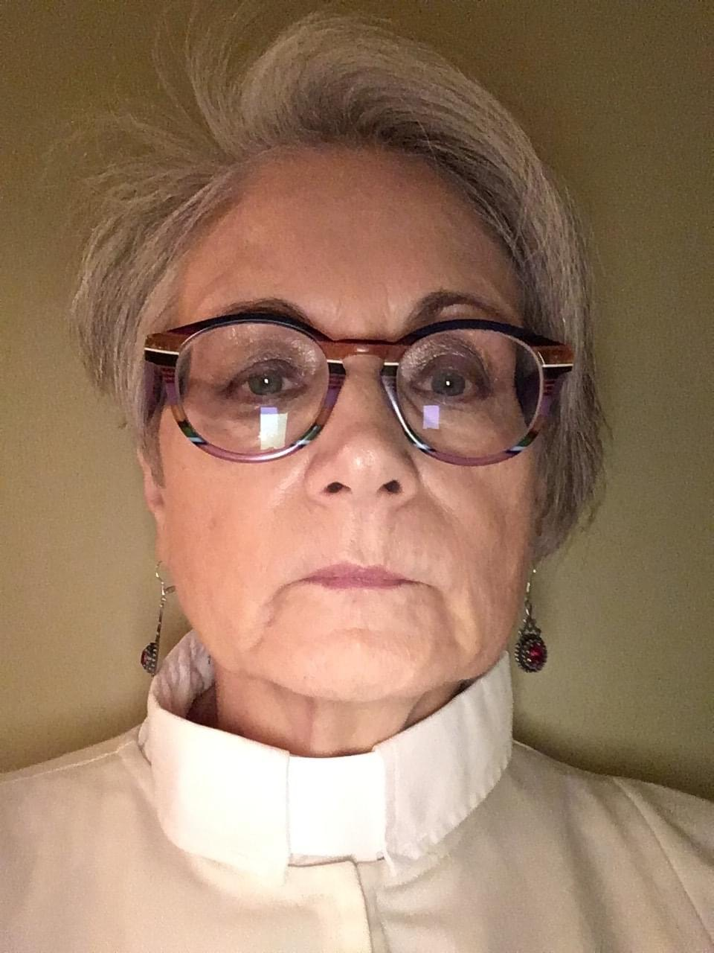

Pastor Ernie Skujins Pastor Rasma Caune

The Frohe Runde’s Outing:

On Wednesday May 31, 2023 our group traveled with Mary Morton Tours
On their Cuesta Country: Over the Hills to Georgian Bay Tour.
We departed from our church at 9:15 in the morning.

We joined Historian and Author Ron Brown as we followed the scenic Niagara Escarpment to Collingwood with stops in Creemore to see North America’s smallest jail. Our tour took us through historic villages and in and out of sweeping valleys. In Collingwood, we were able to browse the shops in Blue Mountain Village for 1 hour.. Our group had a very lovely Turkey lunch at Mylar and Loretta’s in Singhampton.

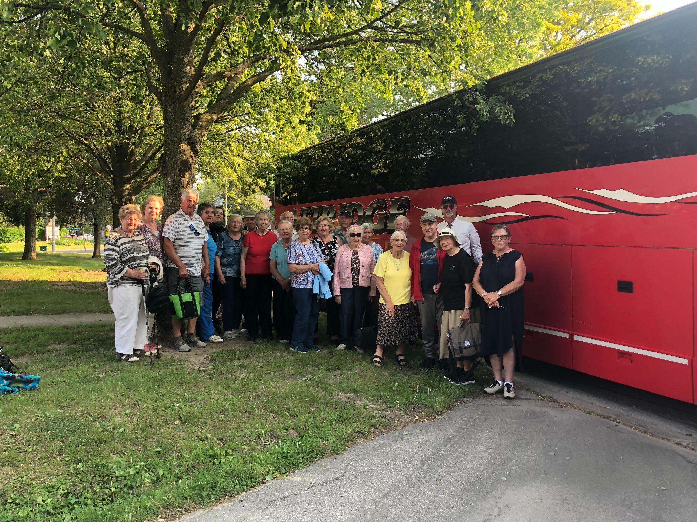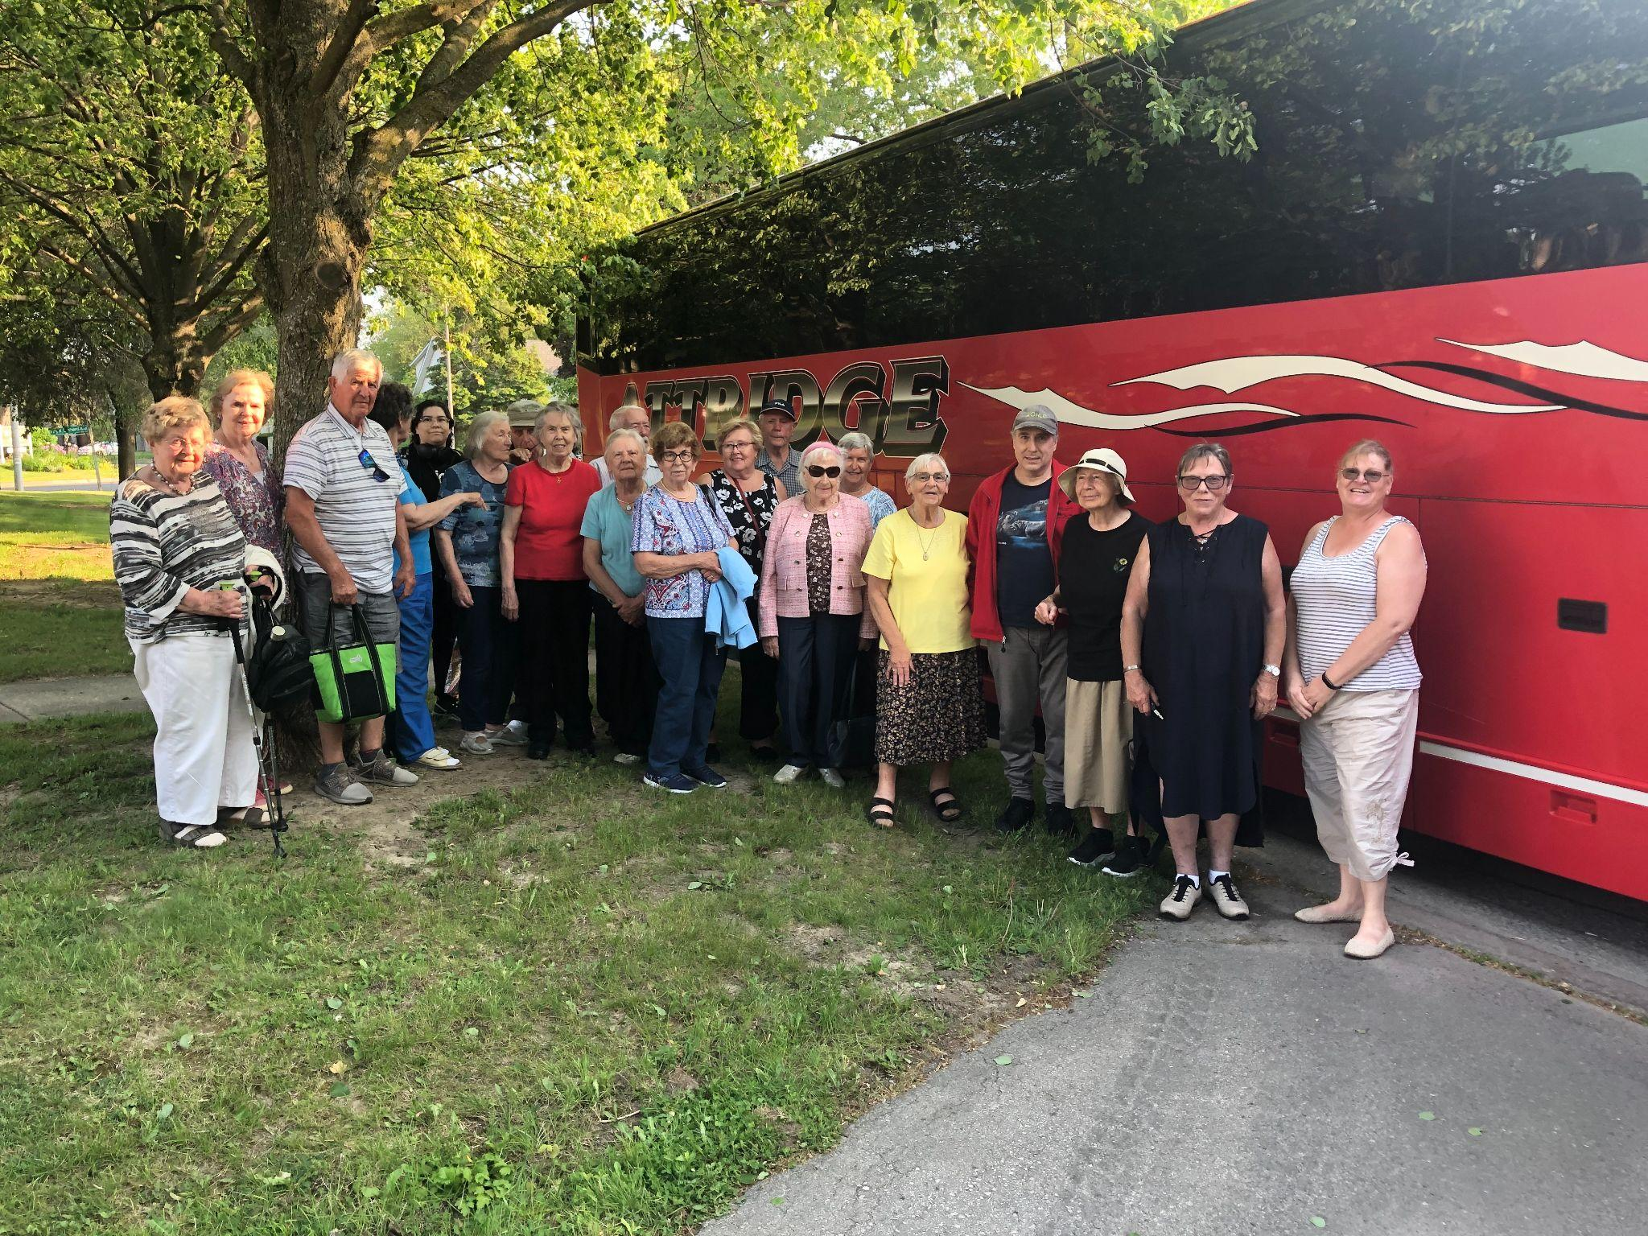
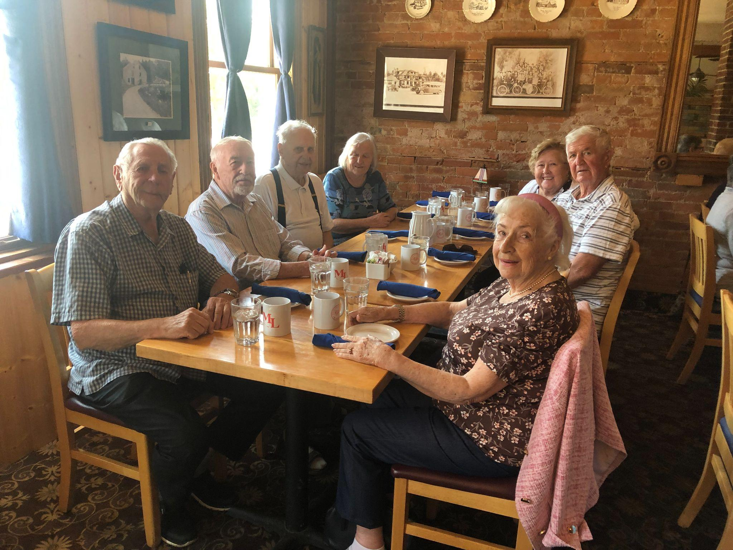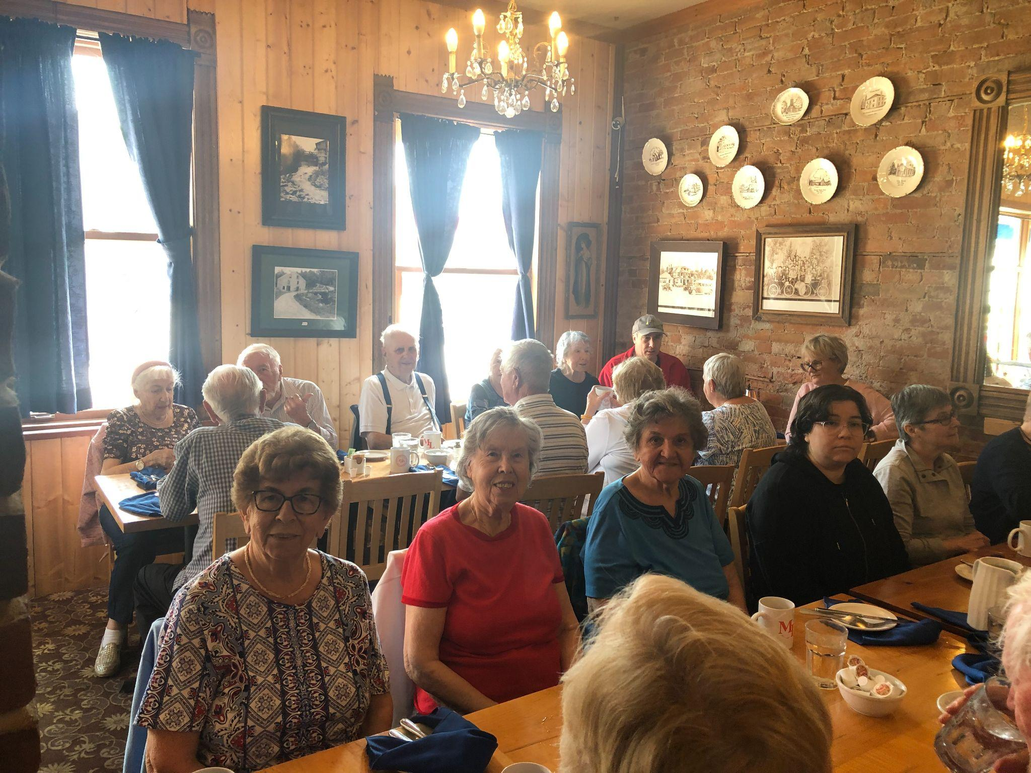

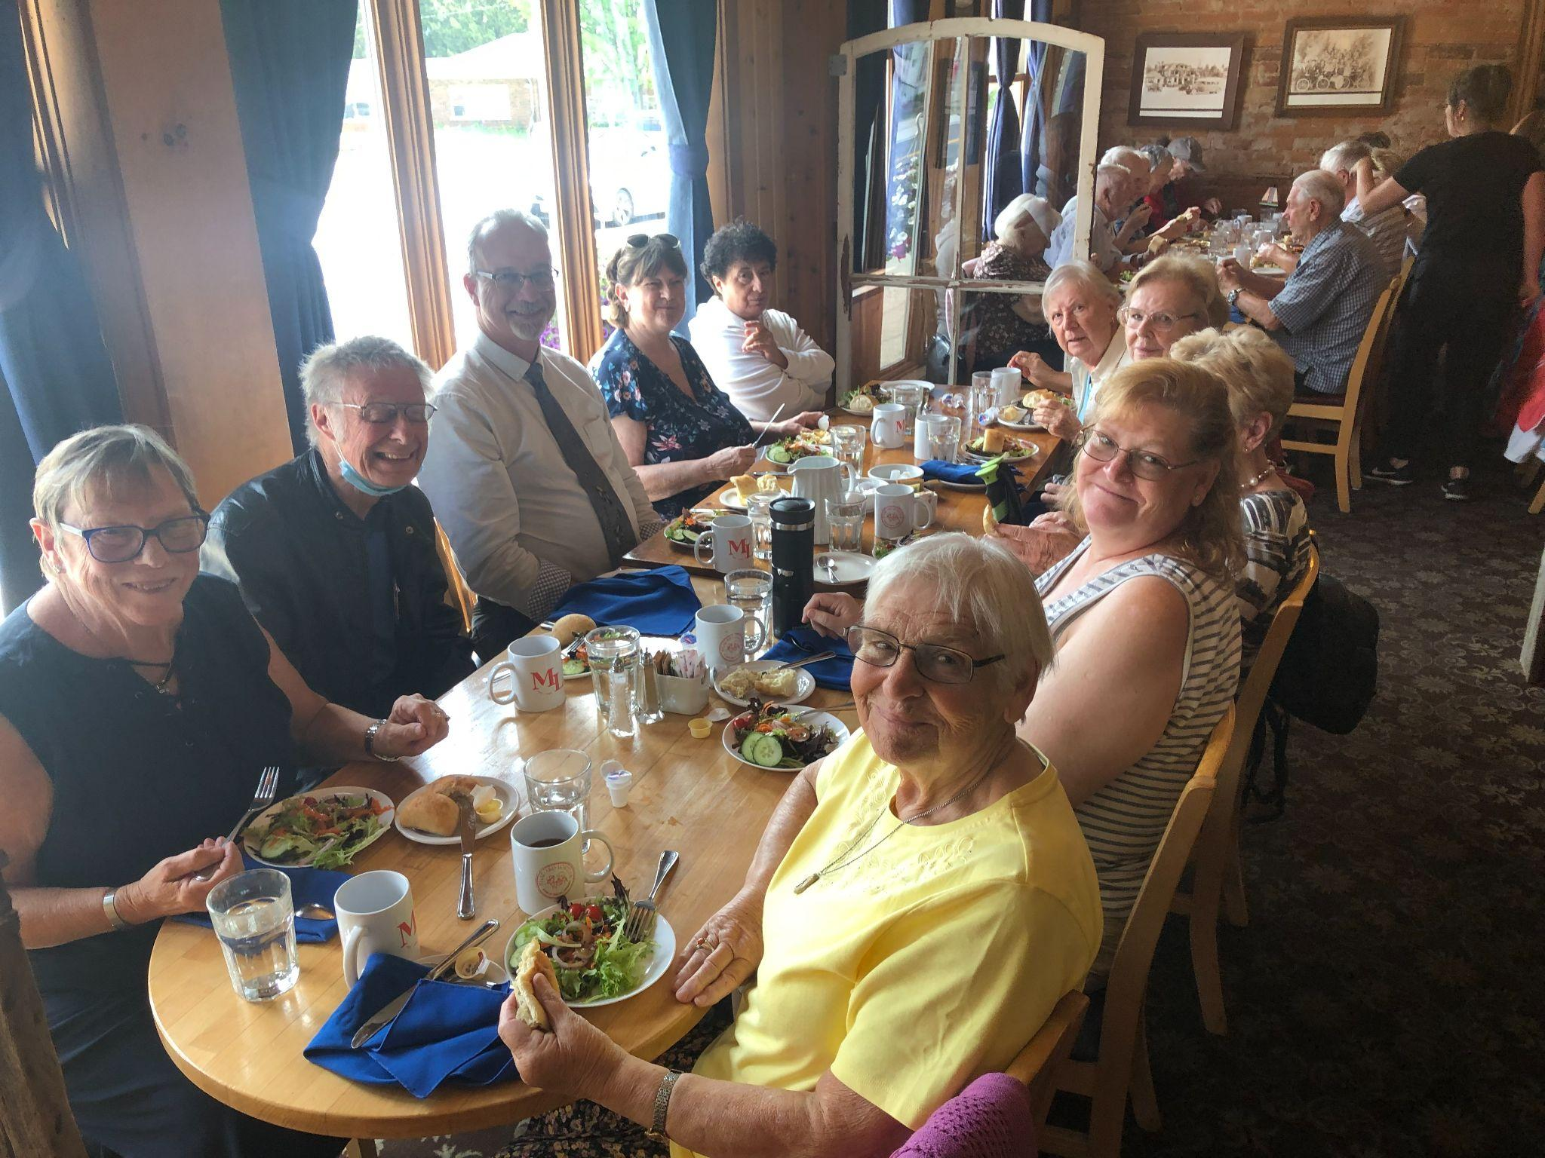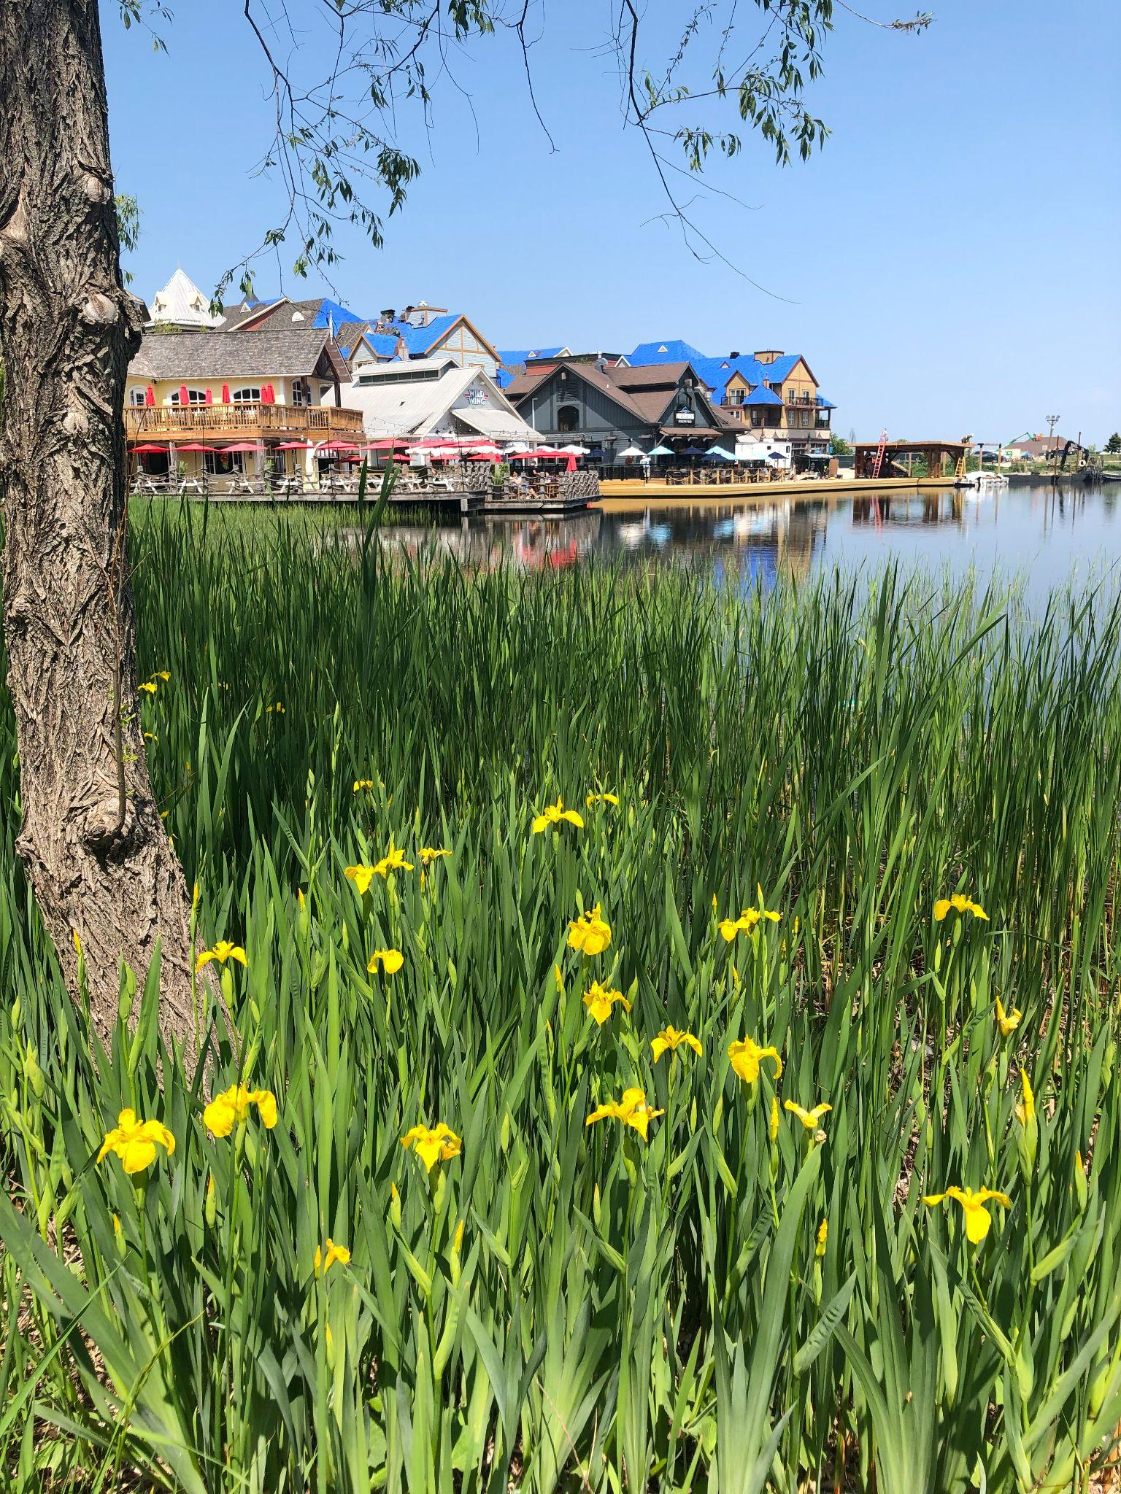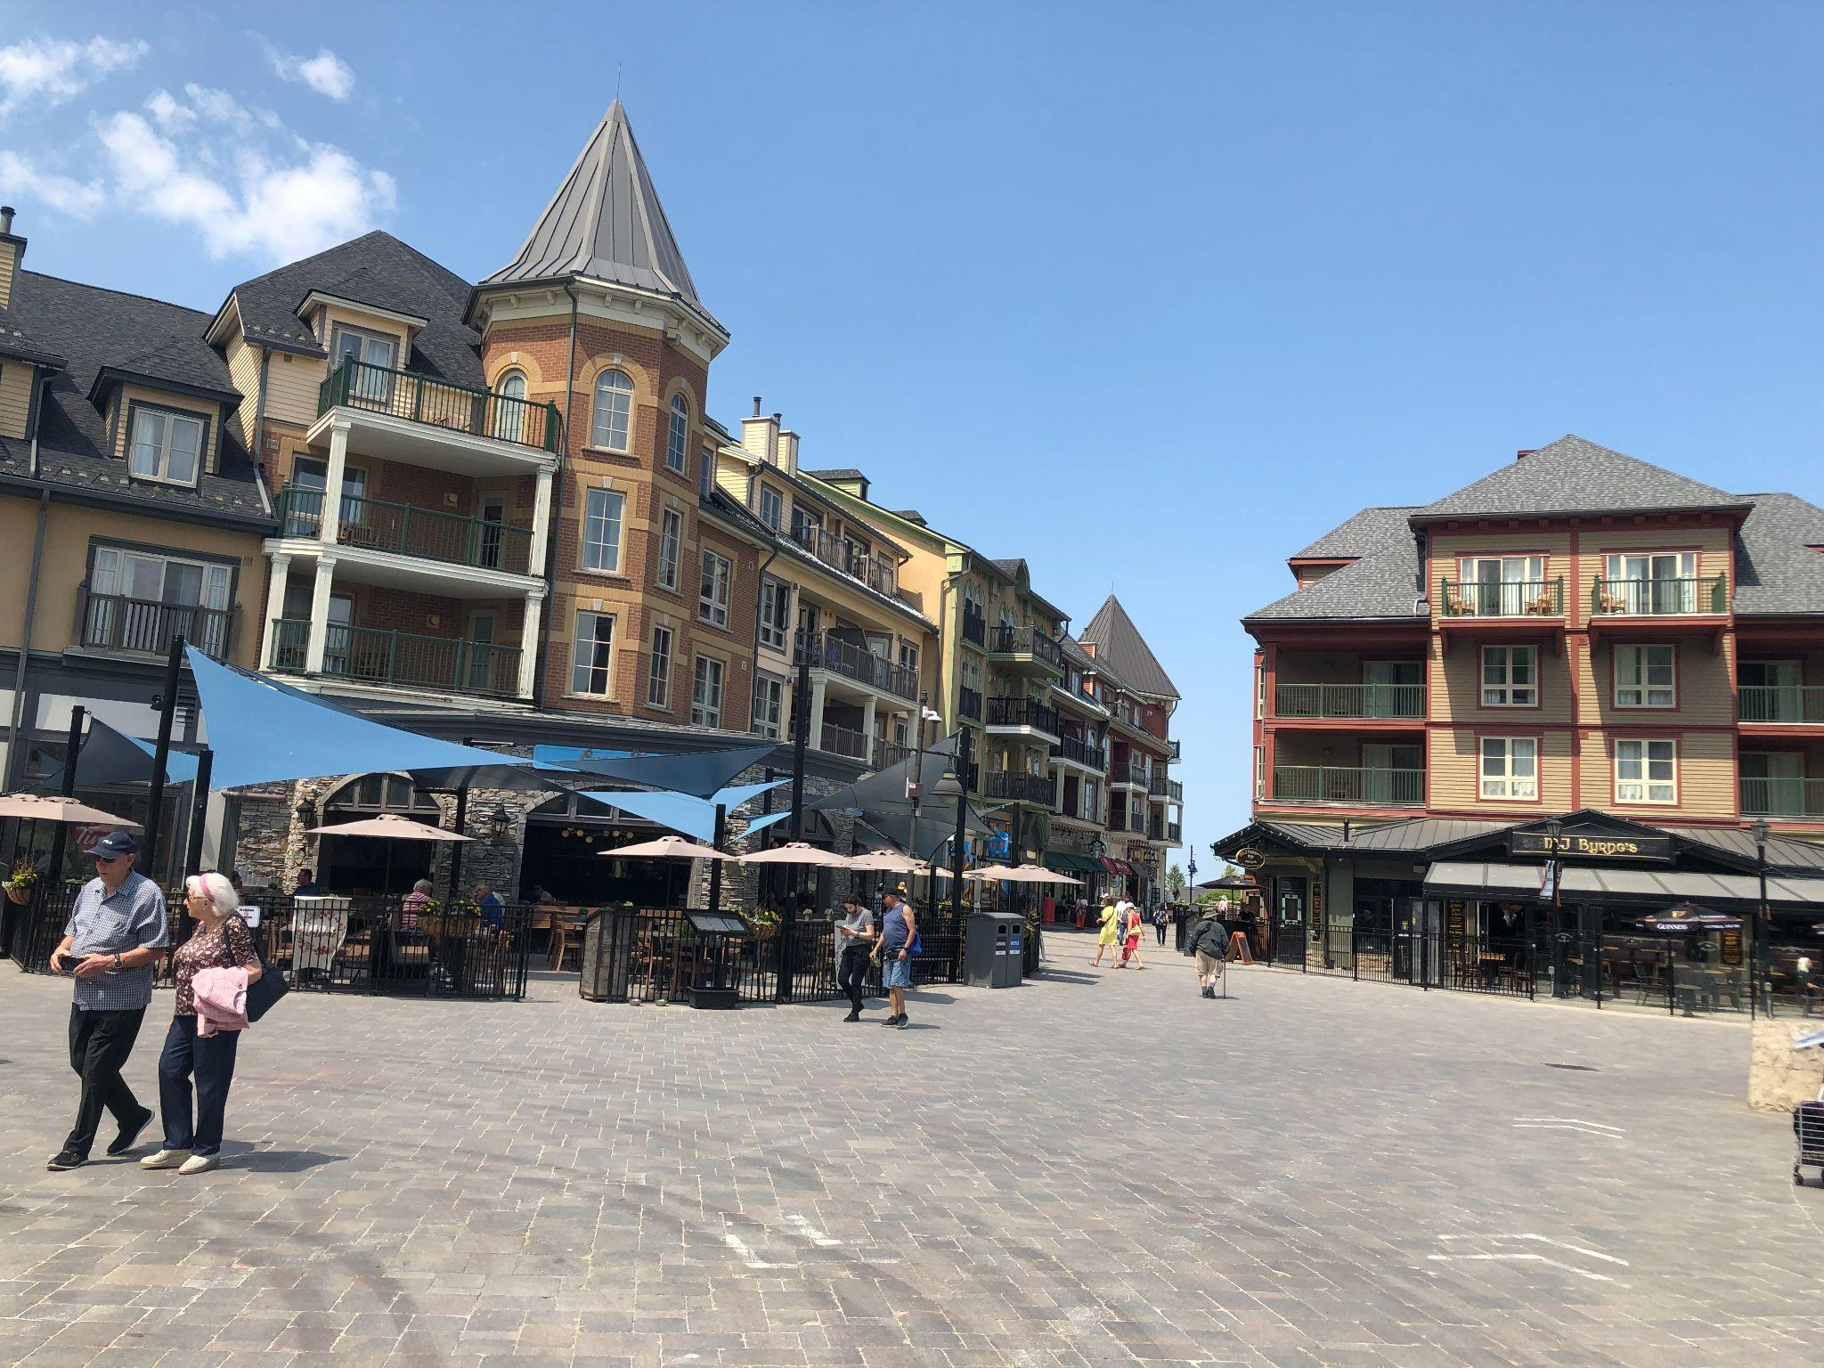

A Very Happy Birthday to:

Karin Baar Edith Baldik Ruth Boothby
Irene Busse David Dunn Gerhard Jurgeneit Erika Koepke Elfriede McDermid Marika Samuelawitsch
Gary Schaefer Ilse Wanschura Werner Wanschura
Maria Zein

In Memoriam

Correction in date; Our sister in Christ, Ellen Sturm, died at her Nursing Home on March 16th, 2023.

Sigismund Sturm died on Easter Sunday April 9, 2023.

A memorial Service for Ellen and Sigismund Sturm was held at our church on May, 15, 2023.
Please continue to remember the Sturm Family in your prayers.

